

Projekt „Nowa oferta edukacyjna Uniwersytetu Wrocławskiego odpowiedzią na
współczesne potrzeby rynku pracy i gospodarki opartej na wiedzy”

library("maps")
png("francja.png")
map("france",fill=T,col=1:10) #8 KB
dev.off()

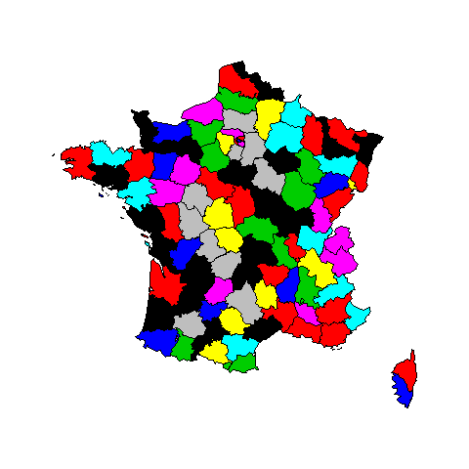

png("francjat.png",
height=4,
width=4,
units="in",res=600)
map("france",fill=T,col=1:10) #51 kB
dev.off()
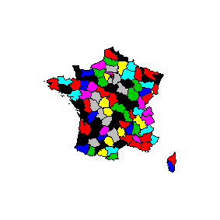

png("francjac.png",
height=12,
width=12,
units="cm",res=600)
map("france",fill=T,col=1:10) #73 kB
dev.off()
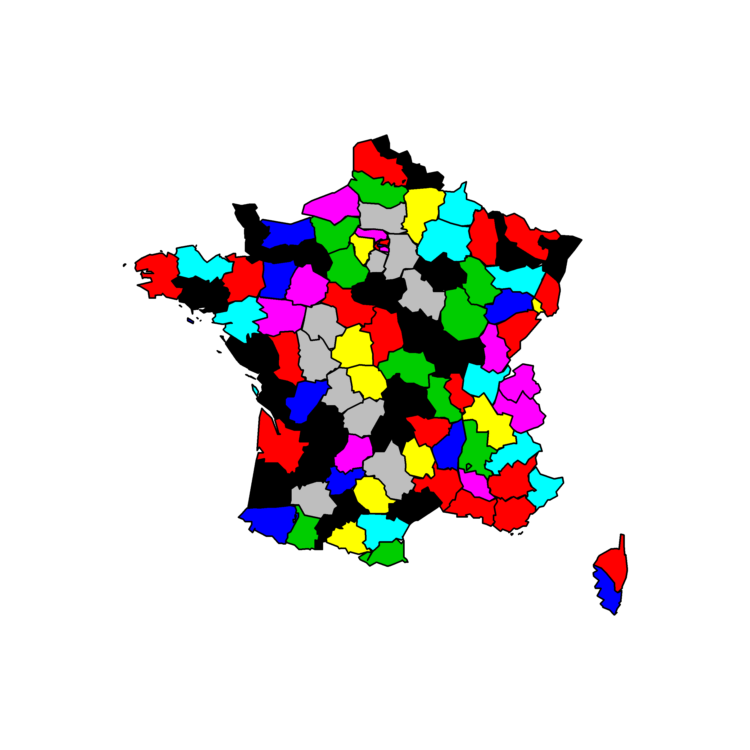

pdf("france.pdf",
height=12,
width=12
)
map("france",fill=T,col=1:10) #127kB
dev.off()

pdf("france1.pdf") # 83 kB
map("france",fill=T,col=1:10)
dev.off()

plot(rnorm(1000),type="n")
x<-par("usr") # tylko przez par();daje współrzędne okna rysunku
rect(x[1],x[3],x[2],x[4],col="lightblue ")
points(rnorm(1000))
plot(rnorm(1000))
par() stosuje założone ustawienia do odwołania

plot(2^c(1:5),10^c(1:5),type="b")

plot(2^c(1:5),10^c(1:5),log="xy",type="b")

plot(rnorm(1000),xlab="",ylab="")
title(xlab="X axis",col.lab="red")
title(ylab="Y axis",col.lab="blue")
#jedyny sposób aby osie były różnych kolorów

# podział osi
plot(rnorm(100),xaxp=c(0,100,10))

library("XML")
© Smarter Poland
kraj <- c("poland", "united_kingdom", "greece", "hungary")
# lista czterech tabel z danymi
dane <- lapply(kraj,
function(k) readHTMLTable(paste("http://www.indexmundi.com/",
k, "/internet-users.html", sep = ""), which = 3,
colClasses = "numeric"))
# wyciągamy lata i procenty użytkowników
lata <- dane[[1]][, 1]
procenty <- as.data.frame(sapply(dane, `[`, 2))

library("RColorBrewer")
kolory <- brewer.pal(9, "Set1")
# c("#E41A1C", "#377EB8", "#4DAF4A", "#984EA3", "#FF7F00", "#FFFF33",
# "#A65628", "#F781BF", "#999999")
matplot(lata, procenty, type = "o", pch = 19, las = 1, xlab = "",
ylab = "", col = kolory, main = "% osób z dostępem do Internetu",
bty = "n")
abline(h = (0:7) * 10, col = "grey", lty = 3)
legend("topleft", kraj, ncol = 2, col = kolory, pch = 19, lwd = 2,
bty = "n", cex = 1)

require(vcd)
data("Arthritis")
Arthritis[1:5,]
ID Treatment Sex Age Improved
1 57 Treated Male 27 Some
2 46 Treated Male 29 None
3 77 Treated Male 30 None
4 17 Treated Male 32 Marked
5 36 Treated Male 46 Marked
cd_plot(Improved ~ Age, data = Arthritis)

*
x <- rnorm(1000)
hx <- hist(x, breaks=100, plot=F)
plot(hx, col=ifelse(abs(hx$breaks) < 1.65, 4, 2),
main="Histogram z ogonami na poziomie 0.1")

# plot z liniami dodatkowymi

with(mtcars,{
plot(wt, mpg, main="Wykres rozrzutu",
xlab="Ciężar samochodu [tys funtów] ", ylab="Miles Per Gallon ",
pch=19)
abline(lm(mpg~wt), col="red")
lines(lowess(wt,mpg), col="blue")
})

library(car)
scatterplot(mpg ~ wt | cyl, data=mtcars,
xlab="Ciężar samochodu [tys funtów] ", ylab="Miles Per Gallon ",
main="Warunkowy",
labels=row.names(mtcars),legend.coords="topright")

scatterplot(mpg ~ wt, data=mtcars,
xlab="Ciężar samochodu [tys funtów] ", ylab="Miles Per Gallon ",
main="box",boxplots="xy"
)

scatterplot(mpg ~ wt, data=mtcars,
xlab="Ciężar samochodu [tys funtów] ", ylab="Miles Per Gallon ",
main="box",boxplots="xy",log="x"
)

# Nałożenie krzywej Gaussa
x <- mtcars$mpg
h<-hist(x, breaks=10, col="red", xlab="mpg",
main="Histogram z krzywą normalną")
xfit<-seq(min(x),max(x),length=40)
yfit<-dnorm(xfit,mean=mean(x),sd=sd(x))
yfit <- yfit*diff(h$mids[1:2])*length(x)
lines(xfit, yfit, col="blue", lwd=2)

# wykres z odrębnymi kolorami dla grup
boxplot(len ~ dose, data = ToothGrowth,
boxwex = 0.25, at = 1:3 - 0.2,
subset = supp == "VC", col = "yellow",
main = "Przyrost zębów świnek morskich",
xlab = "Witamina C [mg]",
ylab = "długość zębów",
xlim = c(0.5, 3.5), ylim = c(0, 35), yaxs = "i")
boxplot(len ~ dose, data = ToothGrowth, add = TRUE,
boxwex = 0.25, at = 1:3 + 0.2,
subset = supp == "OJ", col = "orange")
legend(2, 9,c("Kwas askorbinowy", "Sok pomarańczowy"),
fill = c("yellow", "orange"),bty="n")

# w tytule kopia nazwy

baplot = function(x,y){
xstd = (x - mean(x))/sd(x)
ystd = (y - mean(y))/sd(y)

bamean = (xstd+ystd)/2
badiff = (ystd-xstd)/2

plot(badiff~bamean, pch=20, xlab="suma", ylab="różnica")
# deparse(substitute(varname)) cytuje nazwy danych
title(main=paste("Wykres Blanda-Altmana \n",
deparse(substitute(x)), "i", deparse(substitute(y)),"\n",
"(standaryzowane)"), adj=".5")
#linie rferencyjne w locie
abline(h = c(mean(badiff), mean(badiff)+1.96 * sd(badiff),
mean(badiff)-1.96 * sd(badiff)), lty=2)
}

set.seed(78)
aa = rnorm(50)
bb = aa + rnorm(50)
baplot(aa,bb)

baplot(aa,bb^2)

baplot(1:100,-(1:100)+rnorm(100))

with(mtcars,baplot(mpg,wt))
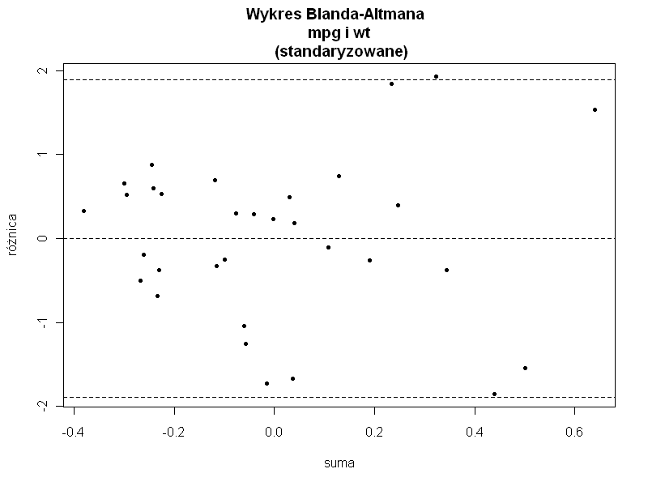
*
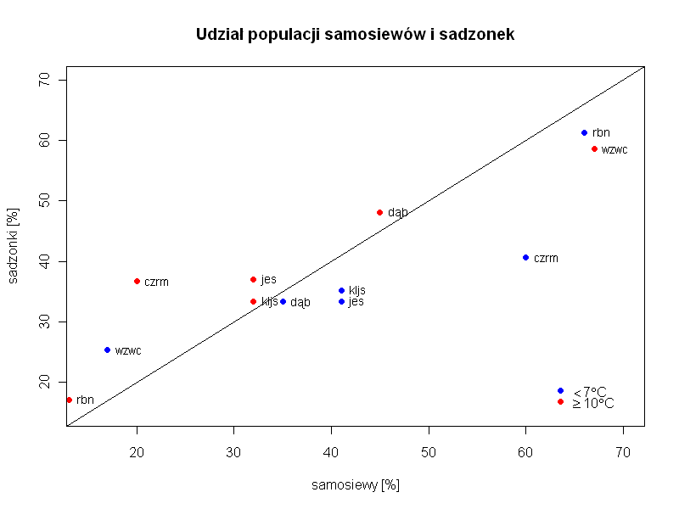

# wykres dwukolorowy; legenda z symbolami matematycznymi
sx<-c(0.32, 0.2, 0.67, 0.32, 0.45, 0.13)*100
sy<-c(0.37, 0.367, 0.586, 0.334, 0.481, 0.171)*100

zx <- c(0.41, 0.6 ,0.17 ,0.41 ,0.35 ,0.66)*100
zy <-c(0.334, 0.406, 0.253, 0.352, 0.333, 0.613)*100

w1<-expression(paste(phantom(0)<7*degree,"C"))
w2<-expression(paste(phantom(0) >= 10*degree,"C"))
plot(sx,sy, col="red",pch=19,ylim=c(15,70),xlim=c(15,70),
main="Udział populacji samosiewów i sadzonek",
xlab="samosiewy [%]",ylab="sadzonki [%]")
text(sx,sy,c("jes","czrm","wzwc","kljs","dąb","rbn"),cex=0.9,pos=4)
abline(0,1)
points(zx,zy,col="blue",pch=19)
text(zx,zy,c("jes","czrm","wzwc","kljs","dąb","rbn"),cex=0.9,pos=4)
legend("bottomright",legend=c(w1,w2),pch=c(19,19),
col=c("blue","red"),cex=1,bty="n",y.intersp=0.3,x.intersp=0.1)

# wykres z dużymi punktami
png("czytelne.png", pointsize=18)

plot(iris[3:4], col=iriscolors[unclass(iris$Species)],#zamiast nazw numerki
main="Iris Data", pch=20)
# etykiety obok średnich pozycje ustalane ręcznie
# (adjusted manually so labels do not overlap points)
text(irismeans[,2]+c(1,1,-1), irismeans[,3]+c(0,-.2,.2),
irismeans[,1])
dev.off()
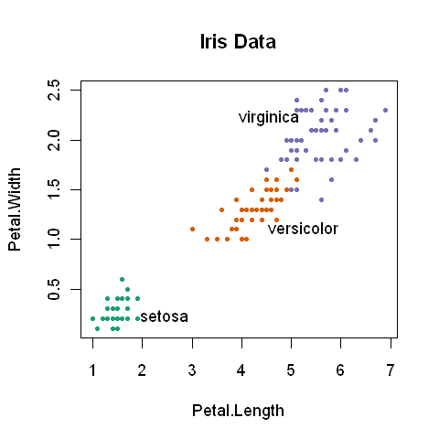
# lepsze na slajdy
png("czytelne 1.png", width=4.5, height=5, units="in",
pointsize=14, res=200)
plot(iris[3:4], bg=iriscolors[unclass(iris$Species)], main="Iris Data",
pch=c(21,22,24)[unclass(iris$Species)], las=1)
text(irismeans[,2]+c(1.5,1.5,-1.5), irismeans[,3]+c(0,-.3,.3), irismeans[,1])
dev.off()
